Very Brief Guide to R (2.1.0) with IPS 5th edition by Moore and McCabe

Gustavo Cepparo, last updated June 25th , 2010

Send comments and corrections to gcepparo@math.utexas.edu
R (2.7.0) is a language and environment for statistical computing and graphics. You can download R (2.7.0) at http://lib.stat.cmu.edu/R/CRAN/ for free.

In order to use the textbook Introduction to the Practice of Statistics, 5th edition datasets more efficiently, I recommend that you make a folder with the shortest path possible from your drive in order to save datasets as Text (ASCII) files that later on will be imported to R. I went to My Computer > Local Disk (C:) then File > New > Folder and name it data R.

Chapter 1

Section 1.1 (Displaying Distributions with Graphs)
Last summer, I asked my M358K students "Do you own a pet?"
14 students answered yes, and 20 answered no.
Now, proceed to open R, and press enter after typing each of the following lines:
> d<-c(14,20)
> barplot(d,xlab="Do you own a pet?",names=c("yes","no"))
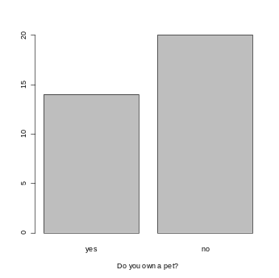
Next, I would like the proportion of yes and no.
> prop.table(d)
[1] 0.4117647 0.5882353
> barplot(prop.table(d),xlab="Do you own a pet?",names=c("yes","no"))

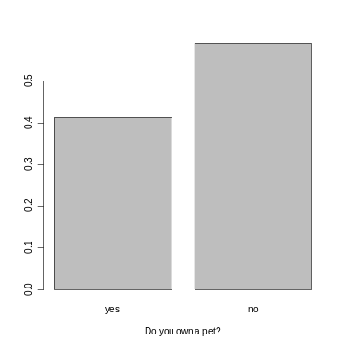

Let's work with Table 1.3 on page 14. Put the CD on your computer and go to My Computer, click on the drive where the CD is located, click on PCDataSets, next click on the Text folder, then Ch01 folder, look for ta01_003 and when you find it, click on it. When the table opens, go to File>Save As... and proceed to save (call it iq) and place the file in the folder you created called data R (See page 1).

Now, proceed to open R and after typing each line below, press enter:

> data<-read.table("C:/data R/iq.txt",header=TRUE)
> attach(data)

Now, to check if everything is in order and if R has accepted your data, type and press enter:

> show(iq)
[1] 145 139 126 122 125 130 96 110 118 118 101 142 134 124 112 109 134 113 81
[20] 113 123 94 100 136 109 131 117 110 127 124 106 124 115 133 116 102 127 117
[39] 109 137 117 90 103 114 139 101 122 105 97 89 102 108 110 128 114 112 114
[58] 102 82 101

> stem(iq)

The decimal point is 1 digit(s) to the right of the |

8 | 129
9 | 0467
10 | 01112223568999
11 | 00022334445677788
12 | 22344456778
13 | 013446799
14 | 25

Note: Split-Stemplot

> stem(iq,2)

The decimal point is 1 digit(s) to the right of the |

8 | 12
8 | 9
9 | 04
9 | 67
10 | 01112223
10 | 568999
11 | 0002233444
11 | 5677788
12 | 223444
12 | 56778
13 | 01344
13 | 6799
14 | 2
14 | 5

Next: Histogram

> hist(iq)
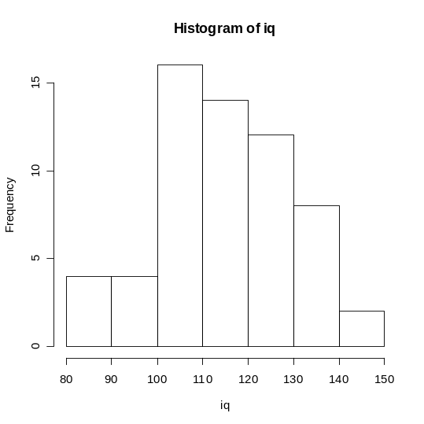

Useless Histograms.
Note: I could change the number of partitions in a histogram for the iq data
> hist(iq,breaks=2)
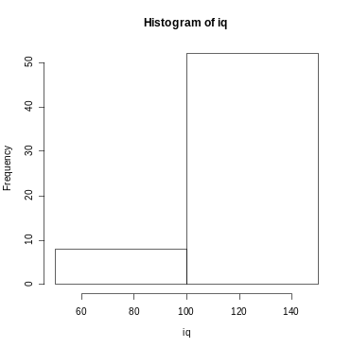

Another useless histogram.
> hist(iq,breaks=50)

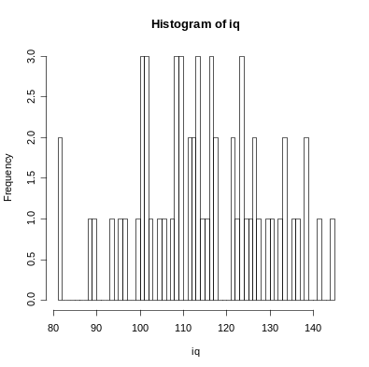
Now, take a look at page 20 and 21.
> data<-read.table("C:/data R/Table1.4.txt",header=TRUE)
> attach(data)
> hist(discharge)
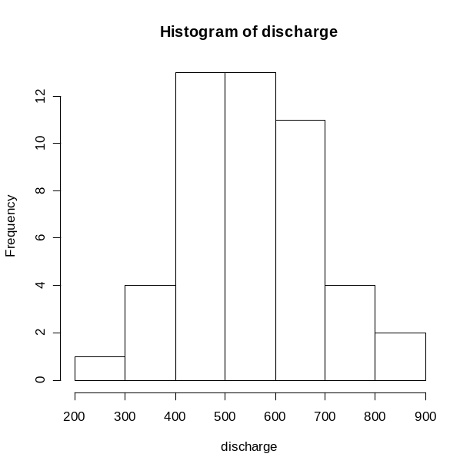
Time Series Plot
> plot(ts(discharge))
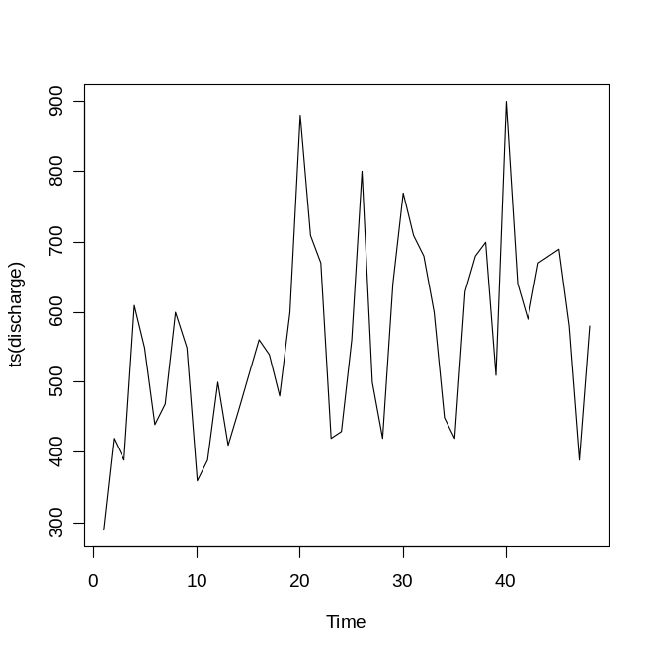

Section 1.2 (Describing Distributions with Numbers)
Mean
> mean(iq)
[1] 114.9833

Using the formula (page 41):
> sum(iq)/length(iq)
[1] 114.9833

Variance
> var(iq)
[1] 219.0675

Using the formula (page 50):
> sum((iq-mean(iq))^2)/(length(iq)-1)
[1] 219.0675

Standard Deviation
> sd(iq)
[1] 14.80093

Using the relationship between standard deviation and variance:
> sqrt(var(iq))
[1] 14.80093

Median
> median(iq)
[1] 114

> summary(iq)
Min. 1st Qu. Median Mean 3rd Qu. Max.
81.0 104.5 114.0 115.0 125.2 145.0

> IQR(iq)
[1] 20.75

Example Stack Data (Problem 1.60, page 60)
> data<-read.table("C:/data R/Problem1.60.txt",header=TRUE)
> attach(data)
> show(data) (Comment: first=data[1:12,] then we can summary(first))
group trees
1 1 27
2 1 22
3 1 29
4 1 21
5 1 19
6 1 33
7 1 16
8 1 20
9 1 24
10 1 27
11 1 28
12 1 19
13 2 12
14 2 12
15 2 15
16 2 9
17 2 20
18 2 18
19 2 17
20 2 14
21 2 14
22 2 2
23 2 17
24 2 19
25 3 18
26 3 4
27 3 22
28 3 15
29 3 18
30 3 19
31 3 22
32 3 12
33 3 12

> boxplot(trees~group)
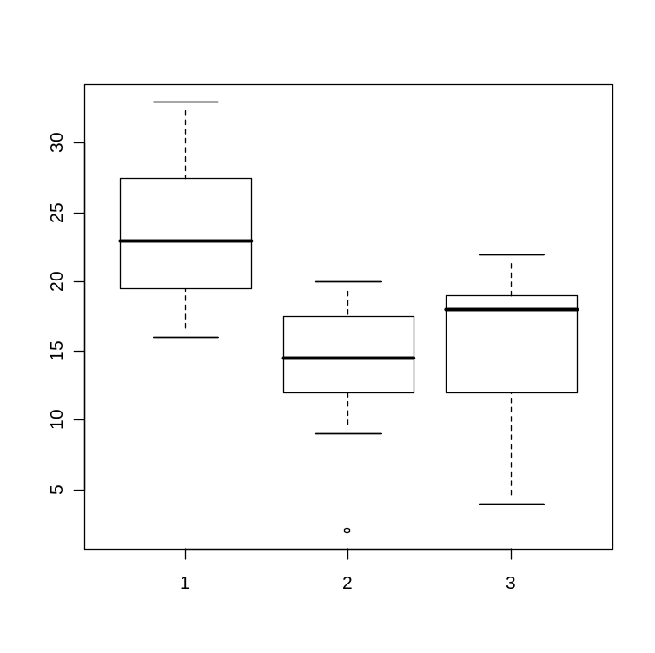

Example Unstack data (Problem 1.60, page 60)
> group1<-c(27,22,29,21,19,33,16,20,24,27,28,19)
> group2<-c(12,12,15,9,20,18,17,14,14,2,17,19)
> group3<-c(18,4,22,15,18,19,22,12,12)
> boxplot(group1,group2,group3)
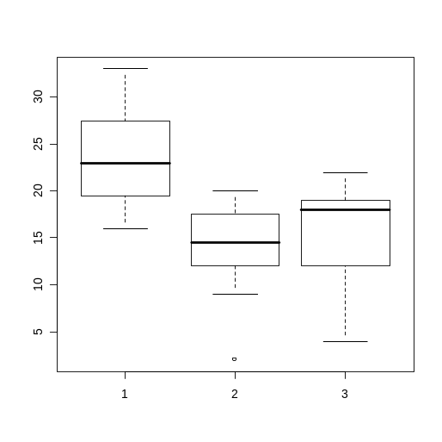
A histogram for each group under the same domain.
> par(mfrow=c(3,1))
> hist(group1,breaks=seq(2,33,length=8))
> hist(group2,breaks=seq(2,33,length=8))
> hist(group3,breaks=seq(2,33,length=8))
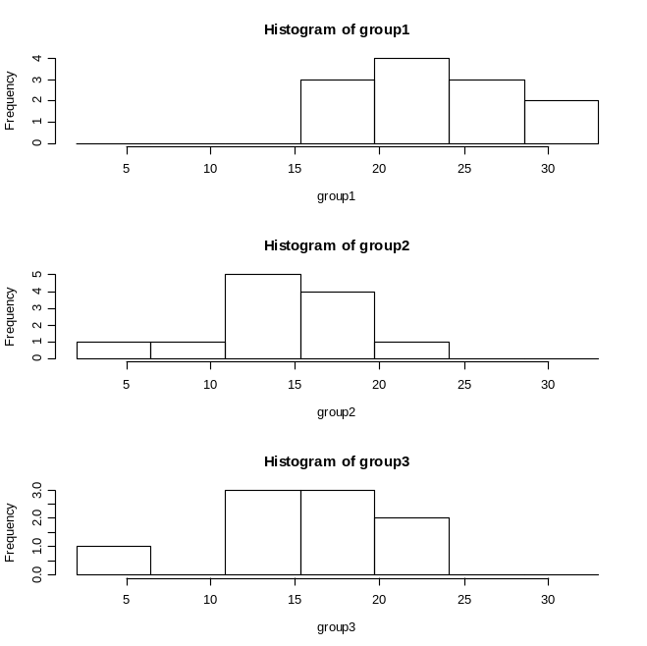

Section 1.3 (Density Curves and Normal Distribution)
Now, let's take a look at page 64 and 65.
Two datasets Rainwater pH and guinea pigs' survival time.
Note: The option prob=TRUE changes the y-axis from count to proportion.
> data1<-read.table("C:/data R/Exer1.30.txt",header=TRUE)
> data2<-read.table("C:/data R/Table1.8.txt",header=TRUE)
> attach(data1)
> attach(data2)
Note: The option prob=TRUE changes the y-axis from count to proportion.
> hist(ph,prob=TRUE,main="",ylab="")
> lines(density(ph))
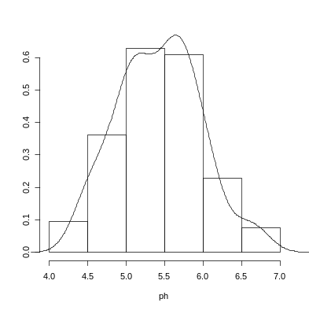
> hist(days,prob=TRUE,main="",ylab="")
> lines(density(days))
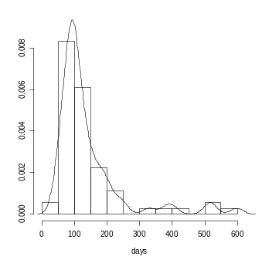
> hist(days,breaks="scott",prob=TRUE,main="",ylab="")
> lines(density(days))
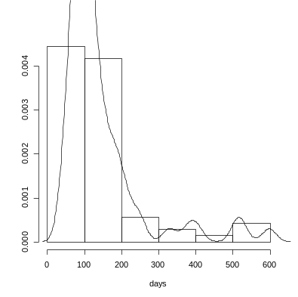
Note: The scott breaks option provides other than the default algorithm for a partition.
Normal Calculations (You need to be able to perform the calculations without technology, showing all work during examinations).
Take a look at Example 1.25 on page 75.
> mu<-1026; sigma<-209
> pnorm(820,mean=mu,sd=sigma)
[1] 0.1621534
> 1-.1621534
[1] 0.8378466

Next, we need inverse (backward) normal calculations, like Example 1.30.
Top 10%
> mu<-505
> sigma<-110
> qnorm(.90,mu,sigma)
[1] 645.9707

Bottom 25%
> qnorm(.25,mu,sigma)
[1] 430.8061

Next, we could make a simulation to test the 68-95-99.7 Rule (page 71).
> simu=rnorm(1000,mean=mu,sd=sigma)
> h=1;sum(simu>(mu - h*sigma) & simu<(mu + h*sigma))
[1] 673
> 673/1000
[1] 0.673
> h=2;sum(simu>(mu - h*sigma) & simu<(mu + h*sigma))
[1] 948
> 948/1000
[1] 0.948
> h=3;sum(simu>(mu - h*sigma) & simu<(mu + h*sigma))
[1] 997
> 997/1000
[1] 0.997

Next, we could find the area between two values with one command line.
> diff(pnorm(c(-1,1)))
[1] 0.6826895
> diff(pnorm(c(-2,2)))
[1] 0.9544997
> diff(pnorm(c(-3,3)))
[1] 0.9973002
Example 1.26 (see page 76)
> diff(pnorm(c(720,820),mean=1026,sd=209))
[1] 0.09057216
Normal quantile plots, page 82 and 83.
> data1<-read.table("C:/data R/Exer1.30.txt",header=TRUE)
> data2<-read.table("C:/data R/Table1.8.txt",header=TRUE)
> attach(data1)
> attach(data2)

> qqnorm(days)
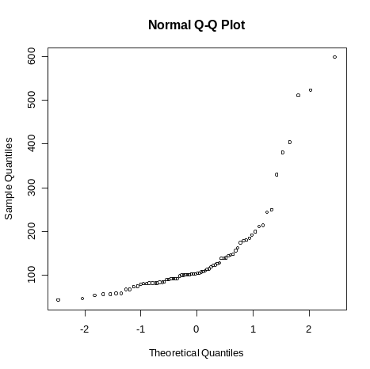

> qqnorm(ph)
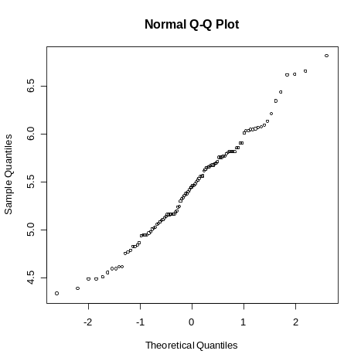

Chapter 2

Section 2.1 (Scatterplots)
Problem 2.12 (page 118, Table 2.2)
> data<-read.table("C:/data R/Table2.2.txt",header=TRUE)
> attach(data)
> show(data)
hav ma
1 28 18
2 32 16
3 25 22
data keeps going...
36 38 20
37 32 37
38 21 23
> plot(ma,hav)
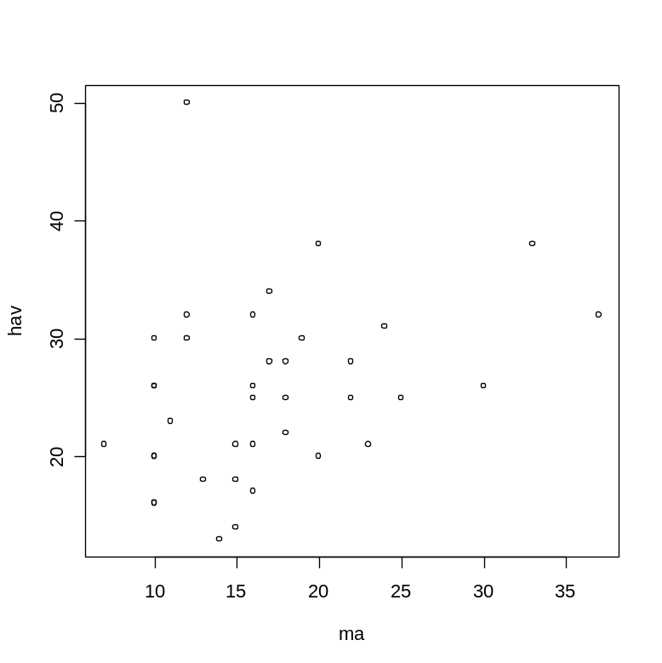

Adding categorical variables to scatterplots (page 106).
Problem 2.17 (page 120, Table 2.3)
> data<-read.table("C:/data R/Table2.3.txt",header=TRUE)
> attach(data)
> show(data)
sex year record
1 M 1912 1880.8
2 M 1921 1840.2
3 M 1924 1835.4
data keeps going......
50 F 1986 1813.7
51 F 1993 1771.8
> plot(year,record,pch=as.character(sex))
> detach(data)
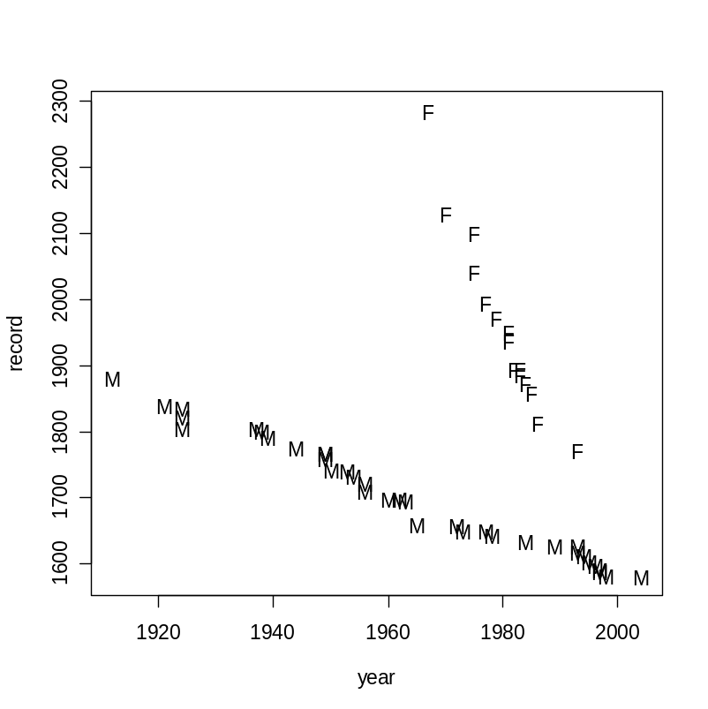

Section 2.2 (Correlation)
Data from Problem 2.12 (page 118, Table 2.2)
> data<-read.table("C:/data R/Table2.2.txt",header=TRUE)
> attach(data)
> cor(ma,hav)
[1] 0.3021368
Correlation using the formula (page 124).
> x<-ma
> y<-hav
> n<-length(x)
> (sum((x-mean(x))*(y-mean(y)))/((n-1)*sd(x)*sd(y)))
[1] 0.3021368
or
> (sum(x*y)-n*mean(x)*mean(y))/((n-1)*sd(x)*sd(y))
[1] 0.3021368

Section 2.3 (Least-Squares Regression)
Example 2.9 (page 132)
> data<-read.table("C:/data R/Example2.9.txt",header=TRUE)
> attach(data)
> show(data)
nea fat
1 -94 4.2
2 -57 3.0
3 -29 3.7
data keeps going.....
14 580 0.4
15 620 2.3
16 690 1.1

> plot(nea,fat,main="Example 2.9",xlab="Nonexercise activity, cal",ylab="Fat gain, kg")
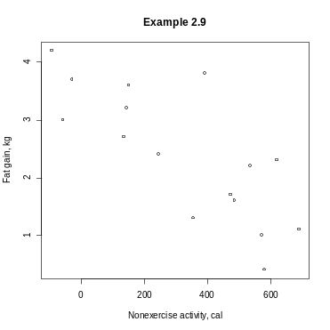
Equation of the Least-Squares Regression Line (page 137)
Long approach by using formulas from page 137.
Slope b:
> b<-cor(nea,fat)*sd(fat)/sd(nea)
> b
[1] -0.003441487

y-Intercept a:
> a<-mean(fat)-b*mean(nea)
> a
[1] 3.505123

Short approach by using linear model command in R.

> lm(fat~nea)

Call:
lm(formula = fat ~ nea)

Coefficients:
(Intercept) nea
3.505123 -0.003441

The summary command in this page with longer output will be useful in Chapter 10. (Inference for Regression)
> model<-lm(fat~nea)
> summary(model)

Call:
lm(formula = fat ~ nea)

Residuals:
Min 1Q Median 3Q Max
-1.1091 -0.3904 -0.1039 0.4126 1.6439

Coefficients:
Estimate Std. Error t value Pr(>|t|)
(Intercept) 3.5051229 0.3036164 11.545 1.53e-08 ***
nea -0.0034415 0.0007414 -4.642 0.000381 ***
---
Signif. codes: 0 '***' 0.001 '**' 0.01 '*' 0.05 '.' 0.1 ' ' 1

Residual standard error: 0.7399 on 14 degrees of freedom
Multiple R-Squared: 0.6061, Adjusted R-squared: 0.578
F-statistic: 21.55 on 1 and 14 DF, p-value: 0.0003810

> plot(fat~nea,main="fat=3.505123-0.003441*nea")
> abline(lm(fat~nea))
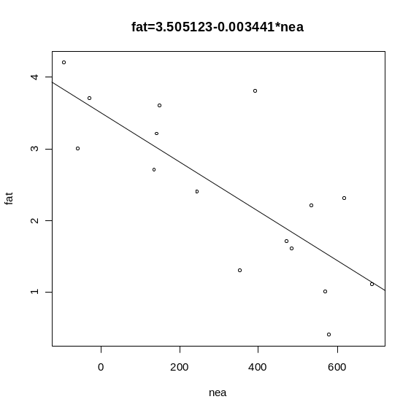
Section 2.4 (Cautions about Correlation and Regression)
> model<-lm(fat~nea)
> residuals(model)
1 2 3 4 5 6
0.37137730 -0.70128768 0.09507396 -0.34052217 0.18700973 0.61454163
7 8 9 10 11 12
-0.26195859 -0.98339502 1.64394000 -0.17729955 -0.23256022 0.53607265
13 14 15 16
-0.54003382 -1.10906043 0.92859905 -0.03049686

Residual Plots (page 153)

> plot(nea,residuals(model))
> abline(lm(residuals(model)~nea))
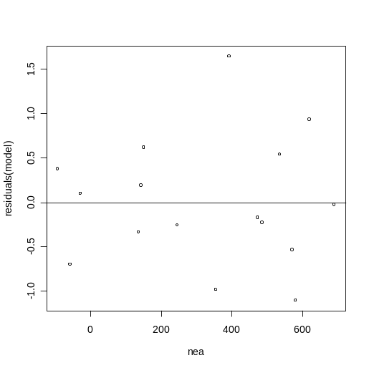

Outliers and Influential Observations
Example 2.17 (page 2.17)
> data<-read.table("C:/data R/Table2.5.txt",header=TRUE)
> attach(data)
> show(data)
obs hba fpg
1 1 6.1 141
2 2 6.3 158
data keeps going....
17 17 13.7 147
18 18 19.3 255

> plot(fpg~hba)
> identify(hba,fpg,n=1)
[1] 15
> identify(hba,fpg,n=1)
[1] 18
> abline(model)
Note: after you type the identify command go with the cursor and click on the observation on the scatterplot and the observation number will appear.
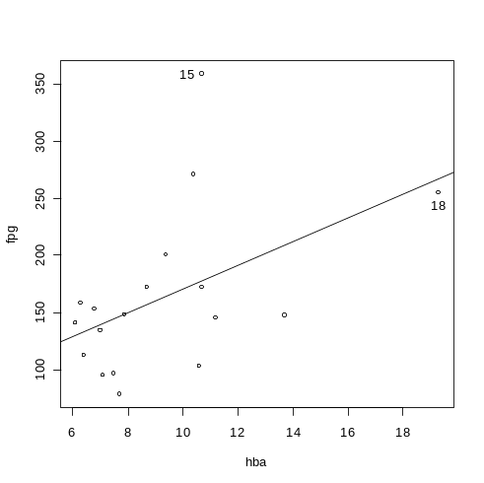

> residuals(model)
1 2 3 4 5 6
11.0846297 26.0030930 -21.0376753 15.7992513 -5.2822854 -45.3230537
7 8 9 10 11 12
-48.4861271 -68.5676638 -0.6492005 15.0246528 35.7392743 96.3315909
13 14 15 16 17 18
-73.7499458 -5.7907141 181.2092859 -37.9945559 -62.0137645 -12.2967918

Note that residuals equal y - yhat (see page 151) so y = fpg and yhat = fitted(model).

> fpg-fitted(model)
1 2 3 4 5 6
11.0846297 26.0030930 -21.0376753 15.7992513 -5.2822854 -45.3230537
7 8 9 10 11 12
-48.4861271 -68.5676638 -0.6492005 15.0246528 35.7392743 96.3315909
13 14 15 16 17 18
-73.7499458 -5.7907141 181.2092859 -37.9945559 -62.0137645 -12.2967918

> plot(fpg~hba)
> abline(lm(fpg~hba))
> abline(lm(fpg~hba,subset=-2))
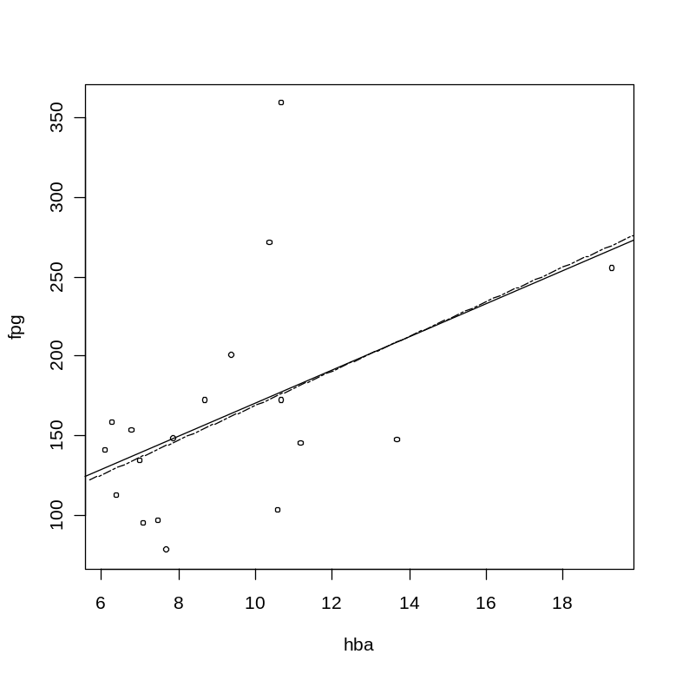
Note: The subset command graphs a second regression line without the ith observation (explanatory variable, ith = -i, that is 2nd=-2). See page 17, show(data). The second observation was entered as (6.3, 158) and does not count when computing the dash least squares line.
Influential Observations
Below, we have a bubble scatterplot. Every observation has some influence over the slope, and the bubble size is directly proportional related to the influence.
> model<-lm(fpg~hba)
> plot(fpg~hba,cex=10*sqrt(cooks.distance(model)))
> abline(model)
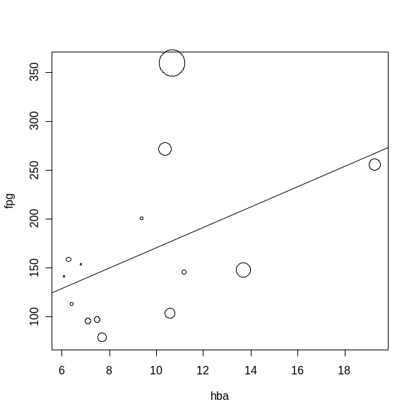
> model<-lm(fpg~hba)
> summary(model)

Call:
lm(formula = fpg ~ hba)

Residuals:
Min 1Q Median 3Q Max
-73.750 -43.491 -5.536 15.606 181.209

Coefficients:

Estimate Std. Error t value Pr(>|t|)
(Intercept) 66.429 46.523 1.428 0.1726
hba 10.408 4.731 2.200 0.0429 *
---
Signif. codes: 0 '***' 0.001 '**' 0.01 '*' 0.05 '.' 0.1 ' ' 1

Residual standard error: 63.82 on 16 degrees of freedom
Multiple R-Squared: 0.2322, Adjusted R-squared: 0.1842
F-statistic: 4.84 on 1 and 16 DF, p-value: 0.04285

Chapter 3 (Producing Data)
Suppose I have 20 experimental units (rats) and 5 treatments (diets). I need to make a random assignment of rats to diets (or diets to rats).
> rats<-c(1,2,3,4,5,6,7,8,9,10,11,12,13,14,15,16,17,18,19,20)
> n=length(rats)
> sample(rats,n,replace=FALSE)
[1] 1 15 13 4 16 20 6 11 18 8 9 2 10 3 17 19 14 12 5 7
Conclusion: Each rat has a collar with a number from 1 to 20. Rat number 1 will go to diet 1, rat number 15 will go to diet 2 and so on.

Suppose I have 9 managers and I have to pick a SRS (simple random sample) of size 4. Four managers must go to Buenos Aires and Santiago.
> managers<-c("Jack", "Samuel"," Maria", "Sofia", "Weilin", "Facundo", "Caleb", "Patricio", "Natalia")
> n=4
> sample(managers,n,replace=FALSE)
[1] "Weilin" "Caleb" "Facundo" "Sofia"
Above we can see the lucky managers.

Sampling Distributions (page 233)
see problem 3.72 (page 242)
> X<-c()
> X<-rbinom(20,1,.5)
> show(X)
[1] 1 1 1 1 0 0 1 1 0 0 0 1 1 1 1 0 1 0 1 1
> phat<-sum(X)/20
> phat
[1] 0.65
> p<-c()
> for (i in 1:100){p[i]=mean(rbinom(20,1,.5))}
> show(p)
[1] 0.60 0.55 0.60 0.60 0.40 0.60 0.35 0.45 0.40 0.20 0.25 0.55 0.45 0.45 0.85
[16] 0.40 0.60 0.55 0.50 0.50 0.60 0.55 0.35 0.45 0.40 0.45 0.55 0.30 0.50 0.50
[31] 0.40 0.50 0.40 0.55 0.75 0.60 0.45 0.65 0.25 0.50 0.70 0.40 0.50 0.45 0.50
[46] 0.40 0.65 0.65 0.60 0.30 0.55 0.45 0.55 0.55 0.55 0.55 0.80 0.50 0.50 0.45
[61] 0.65 0.50 0.50 0.60 0.55 0.45 0.70 0.55 0.40 0.30 0.50 0.50 0.50 0.45 0.65
[76] 0.45 0.60 0.55 0.55 0.65 0.55 0.55 0.50 0.30 0.50 0.50 0.60 0.40 0.55 0.40
[91] 0.40 0.55 0.40 0.60 0.35 0.60 0.45 0.40 0.60 0.15

> stem(p)

The decimal point is 1 digit(s) to the left of the |

1 | 5
2 | 055
3 | 0000555
4 | 000000000000005555555555555
5 | 0000000000000000005555555555555555555
6 | 00000000000000555555
7 | 005
8 | 05

> mean(p)
[1] 0.501
Chapter 4 (Probability: The Study of Randomness)

I would like to verify by simulation the result from Problem 4.56 (page 290).
> X1=c()
> for (i in 1:10000){X1[i]=runif(1)}
> X2=c()
> for (i in 1:10000){X2[i]=runif(1)}
> Y<-X1+X2
> par(mfrow=c(3,1))
> hist(X1)
> hist(X2)
> hist(Y)
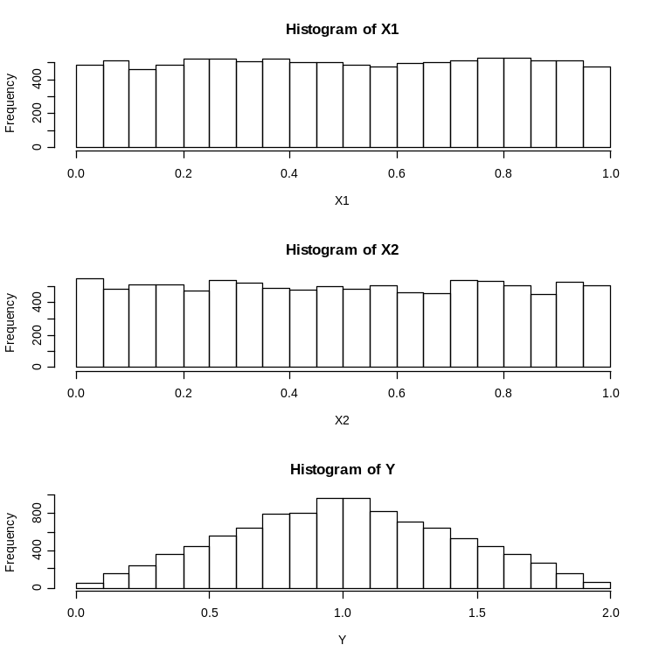
> mean(Y)
[1] 0.999707
Part a
> sum(Y>=0 & Y<=2)/length(Y)
[1] 1
Part b
> sum(Y<=1)/length(Y)
[1] 0.5033
Part c
> sum(Y<=.5)/length(Y)
[1] 0.1257

Problem 4.76, Part a, by simulation.
> par(mfrow=c(3,1))
> X1=c()
> for (i in 1:20000){X1[i]=rnorm(1,100,1.2)}
> X2=c()
> for (i in 1:20000){X2[i]=rnorm(1,100,.85)}
> mean(X1)
[1] 100.0084
> sd(X1)
[1] 1.202926
> mean(X2)
[1] 99.99814
> sd(X2)
[1] 0.8445254
> Y=(X1+X2)/2
> mean(Y)
[1] 100.0033
> sd(Y)
[1] 0.7381367
> hist(X1)
> hist(X2)
> hist(Y)
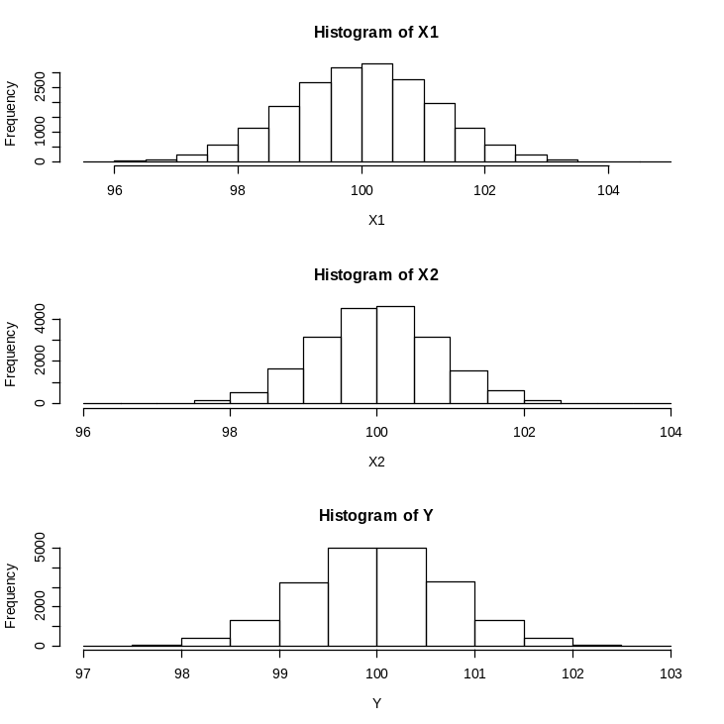

Chapter 5 (Sampling Distributions)

Section 5.1 (Sampling Distributions for Counts and Proportions)
Bernoulli Simulation (Flip a fair coin 20 times)
> n=20;p=1/2
> y<-sample(0:1,size=n, replace=TRUE,prob=c(p,1-p))
> y
[1] 1 1 1 0 1 0 0 1 0 0 1 0 0 0 0 1 1 1 0 0
> sampleprop<-sum(y>0)/n
> sampleprop
[1] 0.45
Bernoulli Simulation, one more time (Flip a fair coin 200 times, Law of large numbers)
> n=200;p=1/2
> y<-sample(0:1,size=n, replace=TRUE,prob=c(p,1-p))
> y
[1] 1 1 0 1 0 0 1 1 0 0 1 0 0 1 0 0 1 0 1 1 0 0 0 0 1 0 0 0 0 0 0 0 0 1 0 0 1
[38] 1 0 0 1 0 0 0 0 1 0 1 0 1 1 0 1 1 1 1 0 1 1 1 0 1 1 1 1 0 0 0 1 0 0 0 0 0
[75] 1 1 1 0 0 1 1 1 1 0 0 1 0 0 1 0 1 0 1 1 0 1 1 0 0 1 1 0 1 1 0 0 1 0 1 1 1
[112] 0 1 1 0 1 0 1 0 1 1 0 1 1 1 0 1 1 0 0 1 1 1 0 0 1 0 1 1 1 1 0 1 0 1 0 0 1
[149] 0 0 1 0 1 1 0 0 1 1 0 1 0 1 0 0 1 0 1 1 0 0 0 0 0 1 0 0 1 1 0 1 0 1 0 0 1
[186] 1 0 1 1 1 0 0 1 1 0 1 0 0 0 1

> sampleprop<-sum(y>0)/n
> sampleprop
[1] 0.495

Binomial. Toss a fair coin 20 times. Let X be the number of heads, X has a Binomial(20, 1/2) distribution.
The probability that X = 10
> choose(20,10)*(1/2)^10*(1-(1/2))^(20-10)
[1] 0.1761971

or

> dbinom(10,size=20,prob=1/2)
[1] 0.1761971

The probability of 10 or fewer heads.

> sum(dbinom(0:10,size=20,prob=1/2))
[1] 0.5880985

or

> pbinom(10,size=20,p=1/2)
[1] 0.5880985
Example 5.6 (page 340)
We want the probability of missing 5 or more.
> choose(12,5)*(1/4)^5*(1-(1/4))^(12-5)
[1] 0.1032414
> choose(12,6)*(1/4)^6*(1-(1/4))^(12-6)
[1] 0.04014945
> choose(12,7)*(1/4)^7*(1-(1/4))^(12-7)
[1] 0.01147127
> choose(12,8)*(1/4)^8*(1-(1/4))^(12-8)
[1] 0.002389848
> choose(12,9)*(1/4)^9*(1-(1/4))^(12-9)
[1] 0.0003540516
> choose(12,10)*(1/4)^10*(1-(1/4))^(12-10)
[1] 3.540516e-05
> choose(12,11)*(1/4)^11*(1-(1/4))^(12-11)
[1] 2.145767e-06
> choose(12,12)*(1/4)^12*(1-(1/4))^(12-12)
[1] 5.960464e-08
Add all answers to find the probability of missing 5 or more out of 12 free throws.
.1576

or

> sum(dbinom(5:12,size=12,prob=1/4))
[1] 0.1576437

or

> 1-pbinom(4,size=12,p=1/4)
[1] 0.1576437

Example 5.7 (Binomial Mean and Standard Deviation by simulation)
Repeat 1000 times
> X=c()
> for (i in 1:1000){X[i]=rbinom(1,2000,.04)}
> mean(X)
[1] 79.729
> sd(X)
[1] 8.843742

Repeat 10000 times
> X=c()
> for (i in 1:10000){X[i]=rbinom(1,2000,.04)}
> mean(X)
[1] 80.1273
> sd(X)
[1] 8.767701
> hist(X)
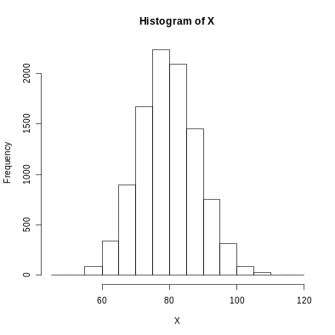

Next, you should make a normal quantile plot (normal probability plot).
> qqnorm(X)
Take a look at the box on page 344.
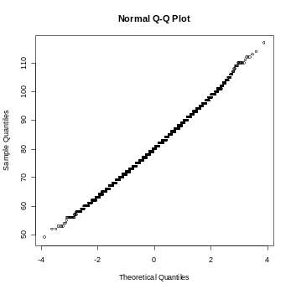

Sample Proportions
Example 5.8 (Normal approximation to Counts and Proportions; Binomial)
p-hat = X/2500
P(p-hat >or= .58)=P(X >or= 1450)=

> n=2500;p=.6
> sum(dbinom(1450:2500,size=2500,prob=.6))
[1] 0.9801803

or

> 1-pbinom(1449,size=2500,prob=.6)
[1] 0.9801803

Example 5.9 and 5.10
p-hat~N(p, sqrt(p(1-p)/n))

> mean=.6
> sigma=sqrt(.6*(1-.6)/2500)
> sigma
[1] 0.009797959
> 1-pnorm(.58,mean=mu,sd=sigma)
[1] 0.9793866

Now, let's work Example 5.8, 5.9, 5.10 by simulation.

> X=c()
> for (i in 1:10000){X[i]=rbinom(1,2500,.6)}
> phat=X/2500
> sum(phat>.58)/10000
[1] 0.9766
> par(mfrow=c(1,2))
> hist(phat)
> qqnorm(phat)
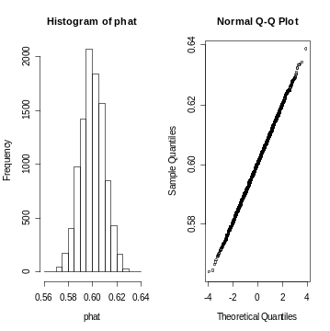
Note: If you make i larger, your simulation will get closer to 0.9801803 by LLN.

Section 5.2 (The Sampling Distribution of a Sample Mean)
Example 5.17
> par(mfrow=c(2,2))
> X1=c()
> for (i in 1:10000){X1[i]=rexp(1,1)}
> hist(X1)
> X2=c()
> for (i in 1:10000){X2[i]=mean(rexp(2,1))}
> hist(X2)
> X10=c()
> for (i in 1:10000){X10[i]=mean(rexp(10,1))}
> hist(X10)
> X25=c()
> for (i in 1:10000){X25[i]=mean(rexp(25,1))}
> hist(X25)
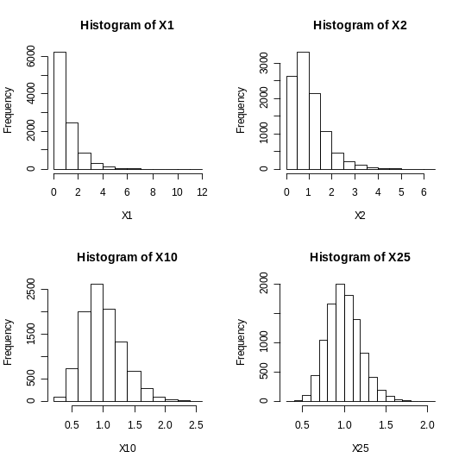
> mean(X1)
[1] 1.000584
> sd(X1)
[1] 0.990438
> mean(X2)
[1] 0.9877089
> sd(X2)
[1] 0.7000309
> mean(X10)
[1] 1.003257
> sd(X10)
[1] 0.3189381
> mean(X25)
[1] 0.9999665
> sd(X25)
[1] 0.1989089

Continue Example 5.17 (page 363)

> par(mfrow=c(2,2))
> hist(X1,prob=TRUE,main="standard deviation = 1",ylab="probability")
> lines(density(X1))
> hist(X2,prob=TRUE,main="standard deviation = 1/sqrt(2)",ylab="probability")
> lines(density(X2))
> hist(X10,prob=TRUE,main="standard deviation = 1/sqrt(10)",ylab="probability")
> lines(density(X10))
> hist(X25,prob=TRUE,main="standard deviation = 1/sqrt(25)",ylab="probability")
> lines(density(X25))
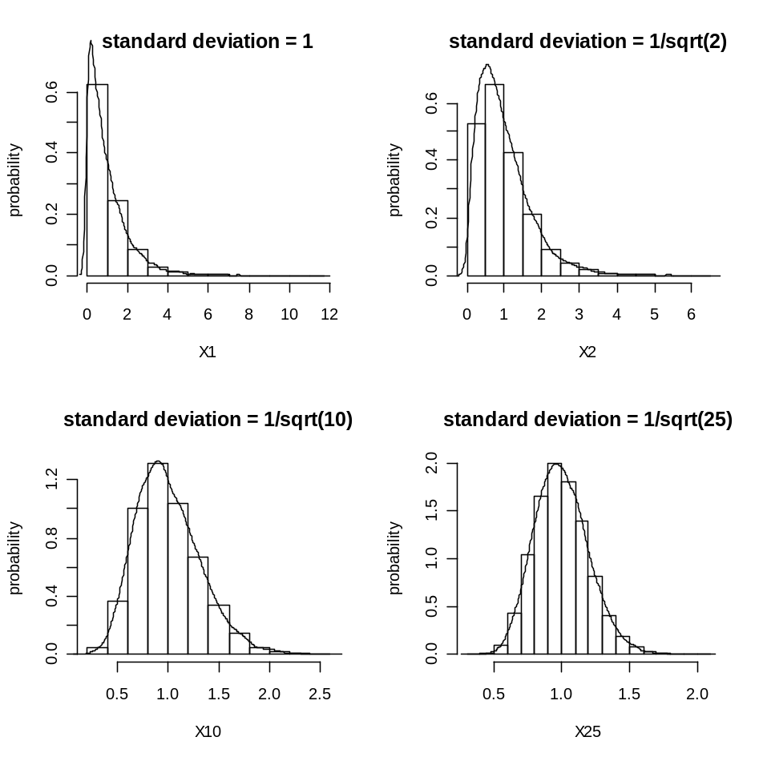

Chapter 6 (Introduction to Inference)
Note: Here is a simulation in order to investigate the sampling distribution of
the random variable (xbar - mu)/(sigma/sqrt(n)). We could change the values
of n = 5, 20, 30, 45...
> n=30; m=250;
> samp=c()
> for(i in 1:m){ Note: after the symbol "{" press enter.
+ x=rnorm(n, 8, .5)
+ samp[i]=(mean(x)-8)/(.5/sqrt(n))
+ }
> qqnorm(samp)
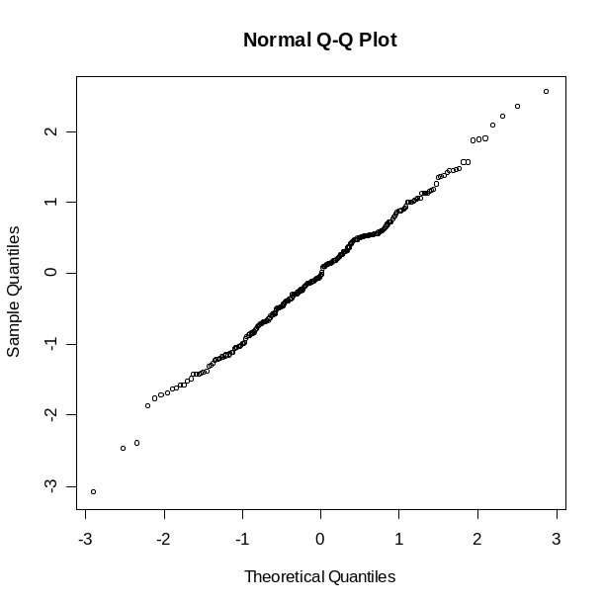

6.1 Estimating with Confidence
Example 6.3
> xbar=18900
> sigma=49000
> n=1280
> alpha=.05
> zstar=qnorm(1-alpha/2)
> ME=zstar*sigma/sqrt(n)
> c(xbar-ME,xbar+ME)
[1] 16215.65 21584.35
We are 95% confident that the mean debt is between $16,216 and $21,584 (rounded to the nearest dollar).

Choosing the sample size “Work here……”

Section 6.2 (Test of Significance)
You will need “TeachingDemos” Package:
Example:
> coffee=c(2.1,1.6,1.3,1.9,1.8,2.2,1.4,2.2,1.6)
> z.test(coffee, sd=.3, alternative="two.sided", mu=2, conf.level=.99)

One Sample z-test

data: coffee
z = -2.1111, n = 9.0, Std. Dev. = 0.3, Std. Dev. of the sample mean = 0.1, p-value = 0.03476
alternative hypothesis: true mean is not equal to 2
99 percent confidence interval:
1.531306 2.046472
sample estimates:
mean of coffee
1.788889

> z.test(coffee, sd=.3, alternative="less", mu=2, conf.level=.99)

One Sample z-test

data: coffee
z = -2.1111, n = 9.0, Std. Dev. = 0.3, Std. Dev. of the sample mean = 0.1, p-value = 0.01738
alternative hypothesis: true mean is less than 2
99 percent confidence interval:
-Inf 2.021524
sample estimates:
mean of coffee
1.788889

Chapter 7 (Inference for Distribution)

Section 7.1 (Inference for the Mean of a Population)
Note: Here is a simulation in order to investigate the sampling distribution of
the random variable (xbar - mu)/(s/sqrt(n)). We could change the values
of n = 5, 20, 30, 45... (see page 451)
> n=30; m=250;
> samp=c()
> for(i in 1:m){ Note: after the symbol "{" press enter.
+ x=rnorm(n, 8, .5)
+ samp[i]=(mean(x)-8)/(.5/sqrt(n))
+ }
> n=30; m=250;
> samp=c()
> for(i in 1:m){
+ x=rnorm(n, 8, .5)
+ samp[i]=(mean(x)-8)/(sd(x)/sqrt(n))
+ }
> samp
[1] -0.380745052 1.094577736 -1.034596328 0.578265989 -0.937788168 0.658739818 0.398682943 0.980639945 -0.061024019 0.874251464 0.005296474
[12] -0.917535745 -0.488275190........samp keeps going.
> qqplot(samp,rt(m, df=n-1))
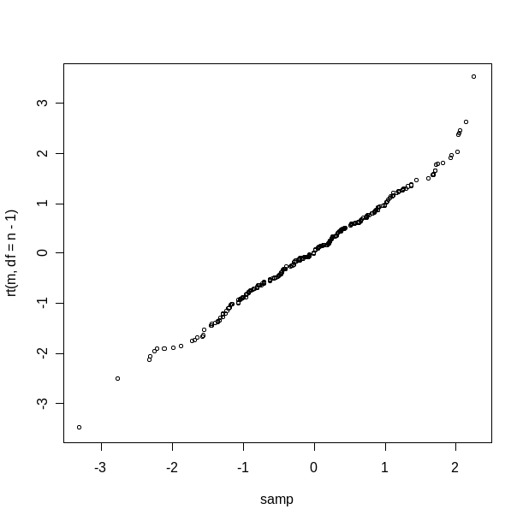

Example 7.1 (page 453)
> x<-c(26,31,23,22,11,22,14,31)
> stem(x)

The decimal point is 1 digit(s) to the right of the |

1 | 14
1 |
2 | 223
2 | 6
3 | 11

> t.test(x)

One Sample t-test

data: x
t = 8.8496, df = 7, p-value = 4.759e-05
alternative hypothesis: true mean is not equal to 0
95 percent confidence interval:
16.48795 28.51205
sample estimates:
mean of x
22.5
I'm 95% confident that the mean vitamin C content of the CSB for this run is between 16.49 and 28.5 mg/100 g.

Example 7.2 (page 454)
> x<-c(26,31,23,22,11,22,14,31)
> t.test(x,mu=40,alternative="two.sided",conf.level=.95)

One Sample t-test

data: x
t = -6.883, df = 7, p-value = 0.0002349
alternative hypothesis: true mean is not equal to 40
95 percent confidence interval:
16.48795 28.51205
sample estimates:
mean of x
22.5

Example 7.3 (page 455)
> x<-c(26,31,23,22,11,22,14,31)
> t.test(x,mu=40,alternative="less",conf.level=.95)

One Sample t-test

data: x
t = -6.883, df = 7, p-value = 0.0001174
alternative hypothesis: true mean is less than 40
95 percent confidence interval:
-Inf 27.31696
sample estimates:
mean of x
22.5

Example 7.4 (page 456)
> data<-read.table("C:/data R/Table7.1.txt",header=TRUE)
> attach(data)
> show(data)
return
1 -8.36
2 1.63
data keeps going......
38 4.33
39 2.35
> t.test(return,mu=.95,alternative="two.sided",conf.level=.95)

One Sample t-test

data: return
t = -2.1365, df = 38, p-value = 0.03914
alternative hypothesis: true mean is not equal to 0.95
95 percent confidence interval:
-3.0394769 0.8425539
sample estimates:
mean of x
-1.098462
Note: Take a look at the confidence interval and read Example 7.5 (page 458).

Example 7.4 continues with graphs in order to check assumptions from page 463.
> hist(return)
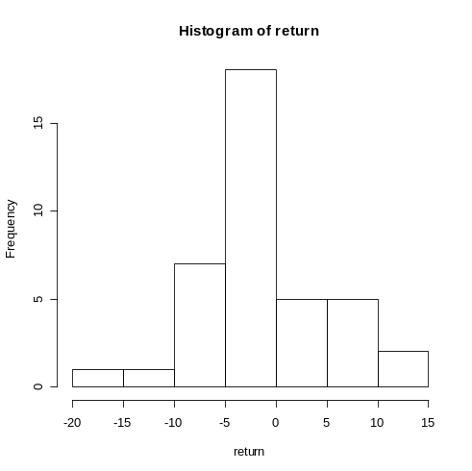
or

> stem(return)

The decimal point is 1 digit(s) to the right of the |

-1 | 5
-1 | 0
-0 | 9998775
-0 | 433333222111111110
0 | 12244
0 | 56777
1 | 22

and

> qqnorm(return)
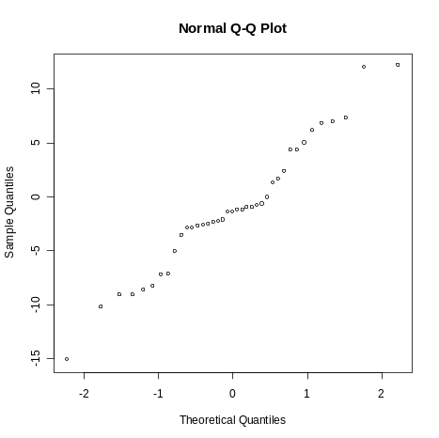

Next, I would like to perform a normality test. I need the package nortest from R cran.
Unzip the package in program's library (R 2.5.0).
In my case, C:\Program Files\R\R-2.5.0\library
Anderson Darling Test for Normality (The null is Normal)
> ad.test(return)

Anderson-Darling normality test

data: return
A = 0.5784, p-value = 0.1238
Conclusion: I fail to reject the null. I do not have enough evidence against normality.
Anyhow, my sample is close to 40 (the t procedures are robust). I just needed to take a look at the stemplot to conclude that it was safe to use t.

Matched Pairs t procedures
Example 7.7 (page 459)
> data<-read.table("C:/data R/Table7.2.txt",header=TRUE)
> attach(data)
> show(data)
patient aggmoon aggother aggdiff
1 1 3.33 0.27 3.06
2 2 3.67 0.59 3.08
data keeps going..............
14 14 0.33 0.23 0.10
15 15 2.00 0.38 1.62
Two ways to perform a Matched Pair t test. Same CI on both outputs, same p-value, same conclusion.
> t.test(aggdiff,mu=0,alternative="two.sided",conf.level=.95)

One Sample t-test

data: aggdiff
t = 6.4518, df = 14, p-value = 1.518e-05
alternative hypothesis: true mean is not equal to 0
95 percent confidence interval:
1.623968 3.241365
sample estimates:
mean of x
2.432667
> t.test(aggmoon,aggother,paired=TRUE,alternative="two.sided",conf.level=.95)

Paired t-test

data: aggmoon and aggother
t = 6.4518, df = 14, p-value = 1.518e-05
alternative hypothesis: true difference in means is not equal to 0
95 percent confidence interval:
1.623968 3.241365
sample estimates:
mean of the differences
2.432667

Next, we should check if it is safe to use t (see page 462).
> stem(aggdiff)

The decimal point is at the |

-0 | 0
0 | 11
1 | 6
2 | 1347
3 | 11167
4 | 44
I would like to perform a normality test.
> ad.test(aggdiff)

Anderson-Darling normality test

data: aggdiff
A = 0.4765, p-value = 0.2028
Conclusion: I fail to reject the null. I do not have enough evidence to conclude that the data is non-normal.
Note: I need caution, my sample size is small and that will affect the power of the normality test.

Section 7.2 (Comparing Two Means)
Example 7.14 (page 489)
> control<-c(42,43,55,26,62,37,33,41,19,54,20,85,46,10,17,60,53,42,37,42,55,28,48)
> treat<-c(24,43,58,71,43,49,61,44,67,49,53,56,59,52,62,54,57,33,46,43,57)
> t.test(treat,control,var.equal=FALSE,alternative="greater",conf.level=.95)

Welch Two Sample t-test

data: treat and control
t = 2.3109, df = 37.855, p-value = 0.01319
alternative hypothesis: true difference in means is greater than 0
95 percent confidence interval:
2.691293 Inf
sample estimates:
mean of x mean of y
51.47619 41.52174

> boxplot(treat, control, names=c("treatment", "control"))
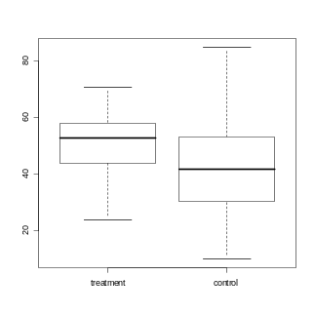
Graphs and quantile plots for both groups (see page 490 and 491).
> stem(control)

The decimal point is 1 digit(s) to the right of the |

0 | 079
2 | 068377
4 | 12223683455
6 | 02
8 | 5

> stem(treat)

The decimal point is 1 digit(s) to the right of the |

2 | 4
3 | 3
4 | 3334699
5 | 23467789
6 | 127
7 | 1

> qqnorm(control)
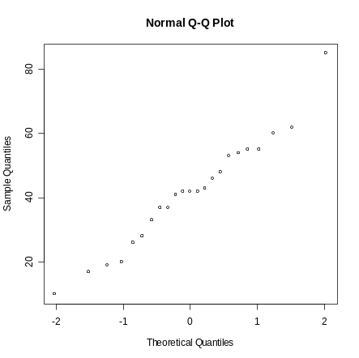
> qqnorm(treat)
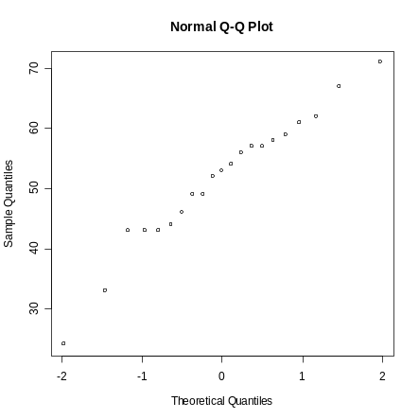
See page 493 for "Robustness of the two-sample procedures".
One more example with stacked data
Height of Tree Data. We have two groups stacked, the 0 group and the 1 group.
Note: When the groups have different sample sizes you should import the data stacked.

> group<-c(0,0,0,0,0,1,1,1,1,1,1,1)
> tree<-c(12,23,14,12,21,41,31,27,24,27,30,34)

> t.test(tree~group)

Welch Two Sample t-test

data: tree by group
t = -4.4866, df = 9.171, p-value = 0.001448
alternative hypothesis: true difference in means is not equal to 0
95 percent confidence interval:
-21.296473 -7.046384
sample estimates:
mean in group 0 mean in group 1
16.40000 30.57143

> t.test(tree~group,var.equal=FALSE,alternative="less",conf.level=.95)

Welch Two Sample t-test

data: tree by group
t = -4.4866, df = 9.171, p-value = 0.000724
alternative hypothesis: true difference in means is less than 0
95 percent confidence interval:
-Inf -8.393575
sample estimates:
mean in group 0 mean in group 1
16.40000 30.57143

Chapter 8 (Inference for Proportions)

Section 8.1 (Inference for a Single Proportion)
Example 8.1 (see page 537).
> prop.test(x=3314, n=17096, conf.level=.95)

1-sample proportions test with continuity correction

data: 3314 out of 17096, null probability 0.5
X-squared = 6408.405, df = 1, p-value < 2.2e-16
alternative hypothesis: true p is not equal to 0.5
95 percent confidence interval:
0.1879610 0.1998703
sample estimates:
p
0.1938465

or

> binom.test(x=3314, n=17096, conf.level=.95)

Exact binomial test

data: 3314 and 17096
number of successes = 3314, number of trials = 17096, p-value < 2.2e-16
alternative hypothesis: true probability of success is not equal to 0.5
95 percent confidence interval:
0.1879440 0.1998533
sample estimates:
probability of success
0.1938465

Example 8.3 (see page 541)
> prop.test(x=68, n=100, p=.75, alternative="two.sided", conf.level=.95)

1-sample proportions test with continuity correction

data: 68 out of 100, null probability 0.75
X-squared = 2.2533, df = 1, p-value = 0.1333
alternative hypothesis: true p is not equal to 0.75
95 percent confidence interval:
0.5782080 0.7677615
sample estimates:
p
0.68
See Example 8.5 (page 544) and compare the confidence intervals.
Next, we have Example 8.3 again without continuity correction.
> prop.test(x=68, n=100, p=.75, alternative="two.sided", conf.level=.95, corr=FALSE)

1-sample proportions test without continuity correction

data: 68 out of 100, null probability 0.75
X-squared = 2.6133, df = 1, p-value = 0.1060
alternative hypothesis: true p is not equal to 0.75
95 percent confidence interval:
0.5833738 0.7633085
sample estimates:
p
0.68

Next, we have Example 8.3 again without normal approximation (an exact test).
> binom.test(x=68, n=100, p=.75, alternative="two.sided", conf.level=.95)

Exact binomial test

data: 68 and 100
number of successes = 68, number of trials = 100, p-value = 0.1070
alternative hypothesis: true probability of success is not equal to 0.75
95 percent confidence interval:
0.5792331 0.7697801
sample estimates:
probability of success
0.68

Choosing a sample size
Note: Here you need to go to Packages, Load package, and select e1071 and BSDA.
Example 8.6 (see page 546).
> nsize(.03, p=.5, type='pi')

The required sample size (n) to estimate the population
proportion of successes with a 0.95 confidence interval
so that the margin of error is no more than 0.03 is 1068 .

Section 8.2 (Comparing Two Proportions)
Example 8.9 (see page 557)
> prop.test(c(1630,1684),c(7180,9916), conf.level=.95,corr=FALSE)

2-sample test for equality of proportions without continuity
correction

data: c(1630, 1684) out of c(7180, 9916)
X-squared = 87.1718, df = 1, p-value < 2.2e-16
alternative hypothesis: two.sided
95 percent confidence interval:
0.04500672 0.06937919
sample estimates:
prop 1 prop 2
0.2270195 0.1698265
I'm 95% confident that the proportion difference is between .0450 and .0694.

Example 8.11 (see page 563)
The output is above, the p-value < 2.2e-16 is very small. Reject the null....

Chapter 9
Section 9.1 (Data Analysis for Two-Way Tables)
Example 9.2 (see page 582)
> data=matrix(c(1630, 5550, 1648, 8232),ncol=2)
> data
[,1] [,2]
[1,] 1630 1648
[2,] 5550 8232
> chisq.test(data)

Pearson's Chi-squared test with Yates' continuity correction

data: data
X-squared = 96.7507, df = 1, p-value < 2.2e-16

or

> chisq.test(data,corr=FALSE)

Pearson's Chi-squared test

data: data
X-squared = 97.1382, df = 1, p-value < 2.2e-16

Section 9.3 (Formulas and Models for Two-Way Tables)

Example 9.18, 9.19, 9.20 (see page 601)
> data=matrix(c(30,11,43,39,1,35,30,19,35),ncol=3)
> data
[,1] [,2] [,3]
[1,] 30 39 30
[2,] 11 1 19
[3,] 43 35 35
> data=matrix(c(30,11,43,39,1,35,30,19,35),ncol=3)
> data
[,1] [,2] [,3]
[1,] 30 39 30
[2,] 11 1 19
[3,] 43 35 35
> chisq.test(data,corr=F)

Pearson's Chi-squared test

data: data
X-squared = 18.2792, df = 4, p-value = 0.001088

Note: Google "R cran TeachingDemos" to find the package TeachingDemos, and Extract all files. In my case, I use the following path C:\Program Files\R\R-2.5.0\library

> chisq.detail(data)

observed
expected

Total
30 39 30 99
34.22 30.56 34.22

11 1 19 31
10.72 9.57 10.72

43 35 35 113
39.06 34.88 39.06

Total 84 75 84 243

Cell Contributions
0.52 + 2.33 + 0.52 +
0.01 + 7.67 + 6.40 +
0.40 + 0.00 + 0.42 = 18.28

df = 4 P-value = 0.001
Section 9.4 (Goodness of Fit)
Example 9.24 (see page 609)
> data=matrix(c(20,133,126,159,136,113,12),ncol=7)
> data
[,1] [,2] [,3] [,4] [,5] [,6] [,7]
[1,] 20 133 126 159 136 113 12
> p=c(1/7,1/7,1/7,1/7,1/7,1/7,1/7)
> chisq.test(data,p=p)

Chi-squared test for given probabilities

data: data
X-squared = 208.8469, df = 6, p-value < 2.2e-16

Chapter 10 (Inference for Regression)

Section 10.1 (Simple Linear Regression)
Example 10.1 (see page 636).
> data<-read.table("C:/data R/MPHandMPG.txt",header=TRUE)
> attach(data)
> plot(MPG~MPH)
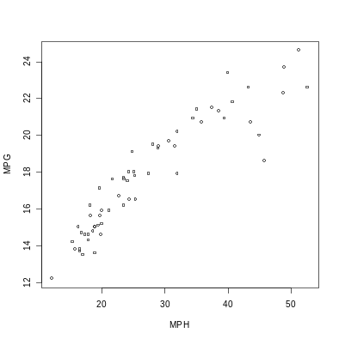
> abline(lm(MPG~MPH))
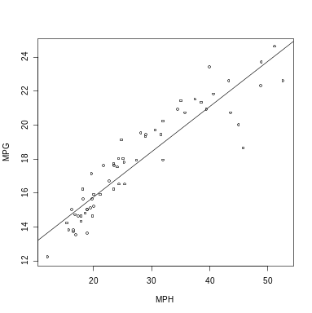
> model<-lm(MPG~MPH)
> plot(MPH,residuals(model))
> abline(lm(residuals(model)~MPH))
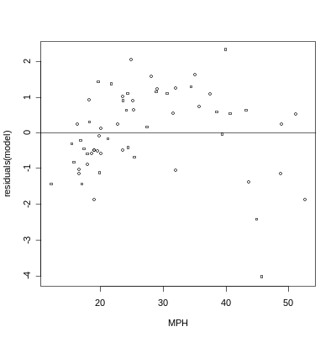
The residuals have some pattern.

Example 10.3 (see page 637)
> LOGMPH<-log(MPH)
> plot(MPG~LOGMPH)
> model<-lm(MPG~LOGMPH)
> abline(model)
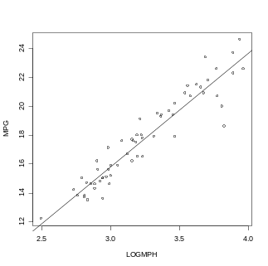
> plot(LOGMPH,residuals(model))
> abline(lm(residuals(model)~LOGMPH))
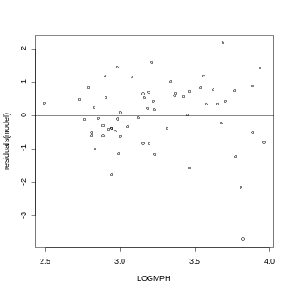
Example 10.4 (see page 640)
> model<-lm(MPG~LOGMPH)
> summary(model)

Call:
lm(formula = MPG ~ LOGMPH)

Residuals:
Min 1Q Median 3Q Max
-3.7170 -0.5188 0.1121 0.6592 2.1492

Coefficients:
Estimate Std. Error t value Pr(>|t|)
(Intercept) -7.7963 1.1549 -6.75 7.69e-09 ***
LOGMPH 7.8742 0.3541 22.24 < 2e-16 ***
---
Signif. codes: 0 '***' 0.001 '**' 0.01 '*' 0.05 '.' 0.1 ' ' 1

Residual standard error: 0.9995 on 58 degrees of freedom
Multiple R-Squared: 0.895, Adjusted R-squared: 0.8932
F-statistic: 494.5 on 1 and 58 DF, p-value: < 2.2e-16

Confidence Interval for a Mean Response
Example 10.8 (see page 648)
> log(30)
[1] 3.401197
> new<-data.frame(LOGMPH=3.401197)
> predict(model, new, se.fit=T, interval='confidence')
$fit
fit lwr upr
[1,] 18.98552 18.7034 19.26764

$se.fit
[1] 0.1409395

$df
[1] 58

$residual.scale
[1] 0.9995164

Prediction Interval for a Future Observation
Example 10.10 (see page 650)
> log(30)
[1] 3.401197
> new<-data.frame(LOGMPH=3.401197)
> predict(model, new, se.fit=T, interval='prediction')
$fit
fit lwr upr
[1,] 18.98552 16.96498 21.00606

$se.fit
[1] 0.1409395

$df
[1] 58

$residual.scale
[1] 0.9995164

Section 10.2 (More Detail about Simple Linear Regression)
Example 10.12 and 10.13 (see page 657)
ANOVA Table

> summary(aov(model))
Df Sum Sq Mean Sq F value Pr(>F)
LOGMPH 1 493.99 493.99 494.47 < 2.2e-16 ***
Residuals 58 57.94 1.00
---
Signif. codes: 0 '***' 0.001 '**' 0.01 '*' 0.05 '.' 0.1 ' ' 1

References

Dalgaard, P. (2002), Introductory Statistics with R, Springer-Verlag.

Moore, D. and McCabe, G. (2006), Introduction to the Practice of Statistics 5th edition, Freeman.

Versani, J. (2005), Using R for Introductory Statistics, Chapman & Hall/CRC.

